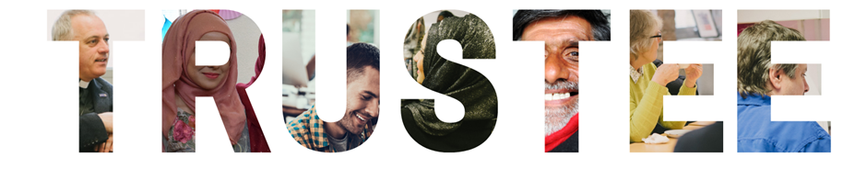

RECRUITMENT PACK



Purpose of this pack

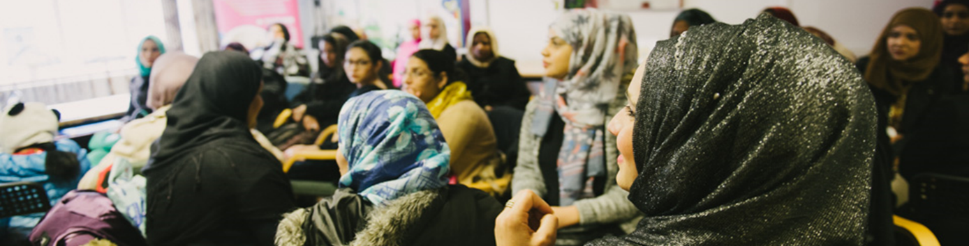

This pack gives key information about Halifax Opportunities Trust and the role/ responsibilities of a Trustee. Please read this carefully before making your application.

If you wish to discuss the role or have any queries, please contact Alison Haskins, CEO of the Trust at alison.haskins@regen.org.uk

Application and Selection Process

The process has three stages:

- You submit your application form by the closing date.
- We will shortlist applicants.
- If shortlisted, we will have an in-person or online meeting to discuss the role and answer any questions you might have. This allows both the applicant and HOT to make a decision about the suitability of the applicant for the role of trustee.
- We will inform you of our decision and explain the next steps.

Applications are invited from people who are over the age of 18 and who live, or work, in Calderdale. We are particularly interested in receiving applications from people who live or work in Park or Warley wards. We would also like to hear from applicants who represent the diverse communities who live in Calderdale. We therefore welcome applications from all suitably qualified persons regardless of their race, sex, disability, religion/belief, sexual orientation or age (as long as you are older than 18). To ensure the board reflects the communities we work within and the people we work alongside, we particularly encourage applications from women, ethnic minorities and people with disabilities.

Please read all the information in this pack to help you make your application.

The deadline for applications for this role is 5pm on Monday 17th November 2025
Follow up meeting: w/c 1st December 2025

Email applications to: recruitment@regen.org.uk or post/drop off: Karen Hardcastle-Rad, Halifax Opportunities Trust, Elsie Whiteley Innovation Centre, Hopwood Lane, Halifax HX1 5ER

After identifying successful candidates, eligibility will be assessed and references taken up, before formally offering a place on the Halifax Opportunities Trust Board. Successful candidates will need to provide ID confirmation and also have a basic DBS check, due to the nature of the activities carried out by Halifax Opportunities Trust.
About Halifax Opportunities Trust

Halifax Opportunities Trust (HOT) is a registered charity. Our purpose is ‘to make a vibrant, multi-cultural and self-sustaining community in Calderdale’.

HOT was established in 2002 and our roots are in the community of Park ward in west Halifax. As time has gone on and the charity has grown and strengthened, it has started to work in other areas across Calderdale whilst always retaining a key presence in Park ward.

The Trust is ‘socially enterprising’ which means it delivers contracts and pursues business opportunities as a way of achieving its charitable goals. This way of working means our organisation doesn’t have to solely rely on donations and grants and we generate much of our income by trading (e.g. the rents we receive from tenants in our buildings; delivering contracts for the council; selling vegetables from the Outback).

HOT has four key values which drive its organisational culture and behaviours. These are: We Care; We are Committed; We are Enterprising; and We Collaborate. Trustees are expected to uphold and protect these values.

The five key areas of activity for the Trust are as follows:

1. We help people find good jobs that meet their aspirations
2. We provide learning opportunities that build skills for life and work
3. We help people to build happy and productive lives in the UK
4. We provide quality space for local businesses
5. We help people to connect with people & activities in their local community

Comprehensive information about all of the Trust’s work can be found on our website www.halifaxopportunitiestrust.org.uk and our various social media channels.

What is the role of a charity trustee?
Trustees have ultimate legal responsibility for a charity’s management and administration. It is important to understand the legal duties of a trustee so that prospective trustees are fully aware of the responsibility and expectations of the role. It is also important to understand that trustees always take decisions collectively so the role of a trustee requires individual capability and a willingness and ability to make joint choices.
The Charities Act 1993 defines charity trustees as ‘those responsible under the charity's governing document for controlling the administration and management of the charity; ensuring it adheres to its charitable objectives and complies with its constitution’.

The specific duties of HOT trustees are to:

- ensure that HOT complies with its governing document (its Articles of Association), charity law, company law and any other relevant legislation or regulations
- ensure that HOT pursues its objects as defined in its governing document
- ensure HOT applies its resources exclusively in pursuance of its objects. For example, it must not spend money on activities which are not included in the objects, however worthwhile they may be
- contribute actively to the board of trustees by giving firm strategic direction to HOT, setting overall policy, defining goals, setting targets, and evaluating performance against agreed targets
- safeguard the good name and values of HOT
- ensure the financial stability of HOT.

In addition to the above statutory duties, each trustee should use any specific skills, knowledge or experience they have to help the board of trustees reach sound decisions. This may involve leading discussions, identifying key issues, providing advice and guidance on new initiatives, and evaluating or offering advice on other areas in which the trustee has particular expertise. Trustees are expected to read board papers in advance of meetings and be prepared to ask questions; offer advice; and take decisions about the information provided. The papers are prepared by members of HOT’s senior management team.

Induction and ongoing training is provided to HOT trustees and a skills audit is regularly carried out to understand where development is needed and to help with recruitment of new trustees.

The trustee board must always act in the best interests of HOT, exercising the same standard of duty of care that a prudent person would apply if looking after the affairs of someone for whom they have responsibility. The trustee board must act as a group and not as individuals.

More detailed information about the legal role of a trustee is available from the Charity Commission website. The Charity Commission is the regulatory agency for all charities in England and Wales. https://www.gov.uk/government/publications/the-essential-trustee-what-you-need-to-know-cc3/the-essential-trustee-what-you-need-to-know-what-you-need-to-do

HOT is also a Company Limited by Guarantee, so the trustees are also directors of the limited company.

Time commitment and expenses

Reimbursement: The role of trustee with HOT is unpaid and voluntary. Expenses incurred to attend meetings (e.g. travel, childcare) are reimbursed.

Hours: Four meetings a year which take place from 4 – 6pm, plus an annual planning half-day, the AGM & a one-off meeting to agree annual accounts. Trustees are also encouraged to join one of the committees of the board. These typically meet four times a year and are held online. Your time commitment will be around 40-50 hours per year.

Location: Usually at Hanson Lane Business Centre, Hanson Lane, Halifax HX1 5PG

Trustees attend an induction session at HOT prior to their first board meeting and other training is provided to trustees to ensure they are informed and confident about their role. Other information about the board which may be useful as follows:

- Papers are distributed one week in advance of meetings.
- There are two ongoing committees: a Finance, Audit and Risk Committee and an Apprenticeships Committee. The committees usually meet online four times a year, for approximately one and a half hours. Task & Finish Groups are also set up to consider and advise on new business opportunities or other matters of importance for the Trust. They typically last for one, two or three sessions.
- Trustees can claim out of pocket expenses incurred in travelling to meetings or care expenses incurred in order to attend meetings.

Person specification

HOT trustees all live or work in the borough of Calderdale and have a broad range of skills and experience. We also seek to ensure that there is fair demographic representation on the board (e.g. gender, ethnicity) so that we are meeting our organisation purpose and our values in all areas of the charity.

Each trustee should have:

• commitment and passion for HOTs purpose
• willingness to meet the minimum time requirement
- willingness to read board papers in advance of meetings
• integrity
• able to see the big picture
• independent judgement
• an ability to think creatively
• willingness to speak their mind
• understanding and acceptance of the legal duties, responsibilities and liabilities of trusteeship
• ability to work effectively as a member of a team and to take decisions for the good of HOT.

The board of trustees collectively needs skills and experience in the following areas:

• experience of living or working in Calderdale
• financial management
• income generation and enterprise, particularly social enterprise
• the regulatory environment for charities and companies
• the voluntary sector
• national and local government and statutory bodies
• community development or community activism
• human resource management
• collaborative partnerships
• social investment and impact

We are currently seeking a new Treasurer, as Leigh Burrows, our current Treasurer, is Chair designate. Please indicate on the application form if you are interested in the Treasurer role.

We particularly encourage applications from women, disabled people and people from ethnic minorities to ensure our board reflects the communities we work in and a range of lived experience. Previous experience of being a trustee is not required; induction and ongoing training is provided for all new trustees.

Halifax Opportunities Trust is an equal opportunities employer and positively encourages applications for trusteeship from suitably qualified and eligible candidates regardless of sex, race, disability, age, sexual orientation, transgender status, religion or belief, marital status, or pregnancy and maternity.

Liability, DBS checks and Conflict of Interests

Liabilities
Trustees are also Directors of HOT, which is a limited company as well as being a registered charity. Directors of companies have additional statutory duties arising from their status under the Companies Act 2006. HOT is incorporated as a company limited by guarantee, this protects and limits the Director's liability to £1, except in exceptional circumstances.

HOT has indemnity insurance to indemnify any of the Directors from liability in the course of fulfilling their duties except for failures by the Board that cannot be insured against such as where a breach occurs resulting in a fine following criminal proceedings or penalty for non-compliance with regulatory requirements. Personal liability of this kind is very rare and Directors who have followed the guidance of the Companies Act and Charities Act will generally be protected.

Disclosure and Barring Service (DBS)
HOT Board members need to undergo a basic DBS check (previously known as a CRB). This is due to the specific activities that HOT carries out.

Conflicts of interest
Applicants should make very clear at the time of application whether any conflicts of interest, or potential conflicts of interest, may arise. These includes themselves and any immediate family. Conflicts of interest do not preclude someone from becoming a trustee, but it is important that HOT is fully transparent about any additional relationships it has with members of its governing body.

Examples of conflicts of interests are:
- Employment with a charity or company that trades with HOT
- A commissioner of HOTs services
- Commercial provision of services to HOT

Exclusion from becoming a trustee
Anyone who fits one of the criteria below may not be a trustee/director:
- Has been disqualified from acting as a company director
- Has been disqualified from acting as a charitable trustee
- An undischarged bankrupt

